**Automated Project Allocation System**

**(APAS)**

Software Engineering Project II – COMP3006L

**Interim Report**

**Team – 6droids**



|  |
| --- |
| **14208971 Tharkana D Kodagoda**  14208893 Sahitha Nelanga H De Silva  14208910 H W Srimal Priyanga Fonseka  14209059 Dilina Namal Weerasinghe  14209074 P W Poorni Yasodara  14209759 Kavindu Yudeesha Lakshan Narathota |

**Table of content**

**1.** **Introduction** 2

**2.** **Project Description** 3

2.1. Requirements (Development) 3

Programming language – Java 3

IDE – NetBeans 3

2.2. Requirements (Implementation) 4

**3.** **Project Design** 5

3.1. Problems and Solutions 5

3.2. Daily/Weekly Scrum Note 5

3.3. Team Roles 6

3.4. Gantt chart 7

3.5. Work break-down structure 10

3.6. Flow Chart 11

3.7. Use-case Diagram 12

3.8. Mock User Interfaces 13

1. **Introduction**

“APAS” is a software solution which will help the user to assign projects to students. To proceed with the system the user has to input a spread sheet with a list of names and preferred projects and then the system will randomly assign projects to each students depending on the weight each of them gained after processing through the algorithm.

When the system start assigning a project to a candidate, the algorithm will check the preferred project list of each candidate and will give the priority to that list (valid mapping). When the system randomly assign projects to candidates, the algorithm will select the item from the most preferred list before going in to other project names. To perform this randomizing part, the system will use one from following algorithms (best mapping).

* Simulated annealing
* Genetic Algorithm

When the system is done performing one of above mentioned algorithms, it will give a status report to the user about the project allocation.

# **Project Description**

* 1. Requirements (Development)

### **Programming language – Java**



Java is a general-purpose computer programming language that is concurrent, class-based, object-oriented, and specifically designed to have as few implementation dependencies as possible. It is intended to let application developers "write once, run anywhere" (WORA), meaning that compiled Java code can run on all platforms that support Java without the need for recompilation.

Source – Wikipedia

### **IDE – NetBeans**



NetBeans is a software development platform written in Java. The NetBeans Platform allows applications to be developed from a set of modular software components called modules. Applications based on the NetBeans Platform, including the NetBeans integrated development environment (IDE), can be extended by third party developers.

Source – Wikipedia

* 1. Requirements (Implementation)

To get a proper output by implementing the system, the user has to have following data in a spreadsheet in the following order.

|  |  |  |  |  |  |  |  |  |  |  |  |
| --- | --- | --- | --- | --- | --- | --- | --- | --- | --- | --- | --- |
| Student Name | Prearranged | Preference 1 | Preference 2 | Preference 3 | Preference 4 | Preference 5 | Preference 6 | Preference 7 | Preference 8 | Preference 9 | Preference 10 |
| Loki Laufeyson | No | 3D printing and augmented reality systems in novel vascular models | 3D stereolithographic models placed in virtual reality as an assist in preoperative planning | Building a 3D room from a Kinect carrying Drone | Drone based re-establishment of communications for humanitarian rescue organisations | Automatic landmark extraction from geo-located flickr images | Mobile and Crowdsourced Community Activism | Forensic Analysis of P2P Instant Messaging | Agent Organisations in ASTRA | Recommending Movies Using Curated IMDb Lists | Twitter Network Analysis |
| Richard B. Riddick | No | A GUI approach to learning how computer networks work | Hebbian Learning in BasicProp | Echo State Network within BasicProp | NS-3 visialisation tool for SUMO generated traffic | Literature Review Assistant | Automatic landmark extraction from geo-located flickr images | Analysis of urban street networks - constructing a dual representation | Markson's Memory | Methodogical Support for Astra | SDN Controller GUI: a mouse based OpenFlow controller |

# **Project Design**

* 1. **Problems and Solutions**

|  |  |
| --- | --- |
| **Problem** | **Solution** |
| How to manage students in a HashTable | * Student ID was maintained separately * Projects were maintained separately so there won’t be any duplicates |
| How to manage current and previous projects in the randomizeAssignment() function | Using a stack |
| How to obtain fitness() function of students | Fitness is inversely proportional to the energy |

* 1. **Daily/Weekly Scrum Note**

Documenting every meeting made our work much easier and efficient. On days we were unable to meet were discussed via Skype and Viber to make it more effective.

Weekly Reports

Weekly meetings were one of the main tasks of the project. In these meetings we discussed about each member updates during the particular week and their contribution toward the project. So each team member is fully aware about the progress of the project and their contribution to the project. These meetings help us to understand our responsibilities. After the meeting we document a summary of the each meeting. Our meeting were held according to this plan.

* **What’s been accomplished since the last meeting?**

At this stage we discussed about what team members accomplished for the past week and how they achieved them. We understood many useful things through this process by discussing those achievements. Meantime weekly meeting spreadsheets were updated with meeting notes and some of them were difficulties we faced and errors needed attention.

* **What needs to be done before the next meeting?**

In this stage whole team discussed about the changes required, improvements need to be done for assigned tasks to run the project smoothly.

* **What obstacles are in the way?**

Here we mainly discussed about strategies and solutions for the obstacles we had during the week and solutions needed to minimize the turnaround time to clear those obstacles.

|  |  |  |  |
| --- | --- | --- | --- |
| **Meeting Date** | **Meeting Time** | **Venue** | **Discussion** |
| 16.06.2016 | Break during the lecture | NSBM Auditorium | This is the first meeting, so we discussed about following things.   * R&D * Weekly meeting structure * Chose a suitable IDE, UI layout * Identified resources for each role |
| 19.06.2016 | 1600 - 1800 | NSBM Study Area | This is the weekly meeting for (17.06.2016 – 18.06.2016)   * Discussed about everyone’s finding on the given tasks. * Check for dependencies of each task and implement a schedule * Assigned new tasks for the team * Flowcharts, WBS, Wireframe designing * Mock UI * R & D further more |
| 25.06.2016 | 1000-1700 | NSBM Study Area | This is the weekly meeting for (20.06.2016 – 24.06.2016)   * Flowcharts, WBS, Wireframe designing reviewed and finalized by the team. * Modified UI * Checked the Interim report up to date |

* 1. **Team Roles**

|  |  |  |
| --- | --- | --- |
| **Task** | **Assigned Persons** | **Follow up** |
| Team Leader | Tharkana |  |
| Report Writers | Poorni / Namal | Kavindu |
| UI Designers | Nelanga / Kavindu | Team |
| Developers | Tharkana / Priyanga / Kavindu |  |
| QA | Poorni / Namal / Nelanga | Team |

* 1. **Gantt chart**

|  |  |  |  |  |  |  |  |  |  |  |  |  |  |  |  |  |  |  |  |  |  |  |  |  |  |  |  |  |  |  |  |  |  |  |  |  |  |  |  |  |  |  |  |  |  |  |  |  |  |
| --- | --- | --- | --- | --- | --- | --- | --- | --- | --- | --- | --- | --- | --- | --- | --- | --- | --- | --- | --- | --- | --- | --- | --- | --- | --- | --- | --- | --- | --- | --- | --- | --- | --- | --- | --- | --- | --- | --- | --- | --- | --- | --- | --- | --- | --- | --- | --- | --- | --- |
| **Project Allocation to Students** | | | | **6/6/2016** | **18** | **7/17/2016** |  | **6** | **7** | **8** | **9** | **10** | **11** | **12** | **13** | **14** | **15** | **16** | **17** | **18** | **19** | **20** | **21** | **22** | **23** | **24** | **25** | **26** | **27** | **28** | **29** | **30** | **1** | **2** | **3** | **4** | **5** | **6** | **7** | **8** | **9** | **10** | **11** | **12** | **13** | **14** | **15** | **16** | **17** |
| Main T# | Sub T# | Task | Assigned person | Start date | #RemD | Due date | Progress | Week #1 | | | | | | | Week #2 | | | | | | | Week #3 | | | | | | | Week #4 | | | | | | | Week #5 | | | | | | | Week #6 | | | | | | |
| 1 |  | Project Managemnet |  | 6/6/2016 | 0.00 | 6/17/2016 | 98.50% |  |  |  |  |  |  |  |  |  |  |  |  |  |  |  |  |  |  |  |  |  |  |  |  |  |  |  |  |  |  |  |  |  |  |  |  |  |  |  |  |  |  |
|  | 1.1 | Assign key Roles | All | 6/6/2016 | 0.00 | 6/12/2016 | 100.00% |  |  |  |  |  |  |  |  |  |  |  |  |  |  |  |  |  |  |  |  |  |  |  |  |  |  |  |  |  |  |  |  |  |  |  |  |  |  |  |  |  |  |
|  | 1.2 | Project Plan | All | 6/10/2016 | 0.00 | 6/17/2016 | 97.00% |  |  |  |  |  |  |  |  |  |  |  |  |  |  |  |  |  |  |  |  |  |  |  |  |  |  |  |  |  |  |  |  |  |  |  |  |  |  |  |  |  |  |
| 2 |  | Research & Development |  | 6/13/2016 | 0.00 | 6/17/2016 | 96.50% |  |  |  |  |  |  |  |  |  |  |  |  |  |  |  |  |  |  |  |  |  |  |  |  |  |  |  |  |  |  |  |  |  |  |  |  |  |  |  |  |  |  |
|  | 2.1 | Select Dev Tools,IDEs ... | All | 6/13/2016 | 0.00 | 6/15/2016 | 98.00% |  |  |  |  |  |  |  |  |  |  |  |  |  |  |  |  |  |  |  |  |  |  |  |  |  |  |  |  |  |  |  |  |  |  |  |  |  |  |  |  |  |  |
|  | 2.2 | Select best GUI libraries | Dev Team | 6/16/2016 | 0.00 | 6/17/2016 | 95.00% |  |  |  |  |  |  |  |  |  |  |  |  |  |  |  |  |  |  |  |  |  |  |  |  |  |  |  |  |  |  |  |  |  |  |  |  |  |  |  |  |  |  |
| 3 |  | Requirement Analysis |  | 6/18/2016 | 0.00 | 6/25/2016 | 90.00% |  |  |  |  |  |  |  |  |  |  |  |  |  |  |  |  |  |  |  |  |  |  |  |  |  |  |  |  |  |  |  |  |  |  |  |  |  |  |  |  |  |  |
|  | 3.1 | WBS | Srimal | 6/18/2016 | 0.00 | 6/23/2016 | 100.00% |  |  |  |  |  |  |  |  |  |  |  |  |  |  |  |  |  |  |  |  |  |  |  |  |  |  |  |  |  |  |  |  |  |  |  |  |  |  |  |  |  |  |
|  | 3.2 | Project Gantt Chart | Srimal | 6/22/2016 | 0.00 | 6/25/2016 | 70.00% |  |  |  |  |  |  |  |  |  |  |  |  |  |  |  |  |  |  |  |  |  |  |  |  |  |  |  |  |  |  |  |  |  |  |  |  |  |  |  |  |  |  |
|  | 3.3 | Dev. Plan | Dev Team | 6/22/2016 | 0.00 | 6/25/2016 | 100.00% |  |  |  |  |  |  |  |  |  |  |  |  |  |  |  |  |  |  |  |  |  |  |  |  |  |  |  |  |  |  |  |  |  |  |  |  |  |  |  |  |  |  |
| 4 |  | UI,UX & Prototyping |  | 6/23/2016 | 0.00 | 6/27/2016 | 66.67% |  |  |  |  |  |  |  |  |  |  |  |  |  |  |  |  |  |  |  |  |  |  |  |  |  |  |  |  |  |  |  |  |  |  |  |  |  |  |  |  |  |  |
|  | 4.1 | Wireframes | Nelanga | 6/23/2016 | 0.00 | 6/25/2016 | 100.00% |  |  |  |  |  |  |  |  |  |  |  |  |  |  |  |  |  |  |  |  |  |  |  |  |  |  |  |  |  |  |  |  |  |  |  |  |  |  |  |  |  |  |
|  | 4.2 | High Fidelity | Nelanga | 6/26/2016 | 0.00 | 6/27/2016 | 0.00% |  |  |  |  |  |  |  |  |  |  |  |  |  |  |  |  |  |  |  |  |  |  |  |  |  |  |  |  |  |  |  |  |  |  |  |  |  |  |  |  |  |  |
|  | 4.3 | UX & UI Review1 | All | 6/27/2016 | 0.00 | 6/27/2016 | 100.00% |  |  |  |  |  |  |  |  |  |  |  |  |  |  |  |  |  |  |  |  |  |  |  |  |  |  |  |  |  |  |  |  |  |  |  |  |  |  |  |  |  |  |
| 5 |  | Architecture |  | 6/23/2016 | 4.00 | 7/3/2016 | 30.00% |  |  |  |  |  |  |  |  |  |  |  |  |  |  |  |  |  |  |  |  |  |  |  |  |  |  |  |  |  |  |  |  |  |  |  |  |  |  |  |  |  |  |
|  | 5.1 | Flow Charts | Tharkana | 6/23/2016 | 0.00 | 6/27/2016 | 100.00% |  |  |  |  |  |  |  |  |  |  |  |  |  |  |  |  |  |  |  |  |  |  |  |  |  |  |  |  |  |  |  |  |  |  |  |  |  |  |  |  |  |  |
|  | 5.2 | Class Diagram | Namal | 6/27/2016 | 2.00 | 7/1/2016 | 20.00% |  |  |  |  |  |  |  |  |  |  |  |  |  |  |  |  |  |  |  |  |  |  |  |  |  |  |  |  |  |  |  |  |  |  |  |  |  |  |  |  |  |  |
|  | 5.3 | High Level Architecture | Srimal | 7/1/2016 | 4.00 | 7/3/2016 | 0.00% |  |  |  |  |  |  |  |  |  |  |  |  |  |  |  |  |  |  |  |  |  |  |  |  |  |  |  |  |  |  |  |  |  |  |  |  |  |  |  |  |  |  |
|  | 5.4 | UI Designings | Nelanga | 6/30/2016 | 4.00 | 7/3/2016 | 0.00% |  |  |  |  |  |  |  |  |  |  |  |  |  |  |  |  |  |  |  |  |  |  |  |  |  |  |  |  |  |  |  |  |  |  |  |  |  |  |  |  |  |  |
| 6 |  | Development |  | 6/30/2016 | 12.00 | 7/11/2016 | 0.00% |  |  |  |  |  |  |  |  |  |  |  |  |  |  |  |  |  |  |  |  |  |  |  |  |  |  |  |  |  |  |  |  |  |  |  |  |  |  |  |  |  |  |
|  | 6.1 | File Handling | Namal | 6/30/2016 | 2.00 | 7/1/2016 | 0.00% |  |  |  |  |  |  |  |  |  |  |  |  |  |  |  |  |  |  |  |  |  |  |  |  |  |  |  |  |  |  |  |  |  |  |  |  |  |  |  |  |  |  |
|  | 6.2 | Develop Basic mapping | Kawindu | 7/1/2016 | 4.00 | 7/3/2016 | 0.00% |  |  |  |  |  |  |  |  |  |  |  |  |  |  |  |  |  |  |  |  |  |  |  |  |  |  |  |  |  |  |  |  |  |  |  |  |  |  |  |  |  |  |
|  | 6.3 | Implement Simulated Annealing (SA) | Srimal | 7/4/2016 | 8.00 | 7/7/2016 | 0.00% |  |  |  |  |  |  |  |  |  |  |  |  |  |  |  |  |  |  |  |  |  |  |  |  |  |  |  |  |  |  |  |  |  |  |  |  |  |  |  |  |  |  |
|  | 6.4 | Implement Genetic Algorithm (GA) | Tharkana | 7/4/2016 | 8.00 | 7/7/2016 | 0.00% |  |  |  |  |  |  |  |  |  |  |  |  |  |  |  |  |  |  |  |  |  |  |  |  |  |  |  |  |  |  |  |  |  |  |  |  |  |  |  |  |  |  |
|  | 6.5 | Define Invalid mappings | Kawindu | 7/6/2016 | 9.00 | 7/8/2016 | 0.00% |  |  |  |  |  |  |  |  |  |  |  |  |  |  |  |  |  |  |  |  |  |  |  |  |  |  |  |  |  |  |  |  |  |  |  |  |  |  |  |  |  |  |
|  | 6.6 | SA Solution & Report Validity | Srimal | 7/8/2016 | 11.00 | 7/10/2016 | 0.00% |  |  |  |  |  |  |  |  |  |  |  |  |  |  |  |  |  |  |  |  |  |  |  |  |  |  |  |  |  |  |  |  |  |  |  |  |  |  |  |  |  |  |
|  | 6.7 | GA Solution & Report Validity | Tharkana | 7/8/2016 | 11.00 | 7/10/2016 | 0.00% |  |  |  |  |  |  |  |  |  |  |  |  |  |  |  |  |  |  |  |  |  |  |  |  |  |  |  |  |  |  |  |  |  |  |  |  |  |  |  |  |  |  |
|  | 6.8 | Bug Resolving | Dev Team | 7/11/2016 | 12.00 | 7/11/2016 | 0.00% |  |  |  |  |  |  |  |  |  |  |  |  |  |  |  |  |  |  |  |  |  |  |  |  |  |  |  |  |  |  |  |  |  |  |  |  |  |  |  |  |  |  |
| 7 |  | QA |  | 7/10/2016 | 16.00 | 7/15/2016 | 0.00% |  |  |  |  |  |  |  |  |  |  |  |  |  |  |  |  |  |  |  |  |  |  |  |  |  |  |  |  |  |  |  |  |  |  |  |  |  |  |  |  |  |  |
|  | 7.1 | Create Test Scenario | Namal | 7/10/2016 | 12.00 | 7/11/2016 | 0.00% |  |  |  |  |  |  |  |  |  |  |  |  |  |  |  |  |  |  |  |  |  |  |  |  |  |  |  |  |  |  |  |  |  |  |  |  |  |  |  |  |  |  |
|  | 7.2 | Unit Testing | Nelanga | 7/12/2016 | 14.00 | 7/13/2016 | 0.00% |  |  |  |  |  |  |  |  |  |  |  |  |  |  |  |  |  |  |  |  |  |  |  |  |  |  |  |  |  |  |  |  |  |  |  |  |  |  |  |  |  |  |
|  | 7.3 | Component Testing | Namal | 7/13/2016 | 15.00 | 7/14/2016 | 0.00% |  |  |  |  |  |  |  |  |  |  |  |  |  |  |  |  |  |  |  |  |  |  |  |  |  |  |  |  |  |  |  |  |  |  |  |  |  |  |  |  |  |  |
|  | 7.4 | Integration Testing | Poorni | 7/14/2016 | 15.00 | 7/14/2016 | 0.00% |  |  |  |  |  |  |  |  |  |  |  |  |  |  |  |  |  |  |  |  |  |  |  |  |  |  |  |  |  |  |  |  |  |  |  |  |  |  |  |  |  |  |
|  | 7.5 | User Testing | All | 7/15/2016 | 16.00 | 7/15/2016 | 0.00% |  |  |  |  |  |  |  |  |  |  |  |  |  |  |  |  |  |  |  |  |  |  |  |  |  |  |  |  |  |  |  |  |  |  |  |  |  |  |  |  |  |  |
| 8 |  | Documentation |  | 6/15/2016 | 18.00 | 7/17/2016 | 48.21% |  |  |  |  |  |  |  |  |  |  |  |  |  |  |  |  |  |  |  |  |  |  |  |  |  |  |  |  |  |  |  |  |  |  |  |  |  |  |  |  |  |  |
|  | 8.1 | Daily Scrum Notes | Poorni | 6/15/2016 | 18.00 | 7/17/2016 | 42.86% |  |  |  |  |  |  |  |  |  |  |  |  |  |  |  |  |  |  |  |  |  |  |  |  |  |  |  |  |  |  |  |  |  |  |  |  |  |  |  |  |  |  |
|  | 8.2 | Weekly Report | poorni | 6/20/2016 | 18.00 | 7/17/2016 | 50.00% |  |  |  |  |  |  |  |  |  |  |  |  |  |  |  |  |  |  |  |  |  |  |  |  |  |  |  |  |  |  |  |  |  |  |  |  |  |  |  |  |  |  |
|  | 8.3 | Interim Report | All | 6/27/2016 | 0.00 | 6/29/2016 | 100.00% |  |  |  |  |  |  |  |  |  |  |  |  |  |  |  |  |  |  |  |  |  |  |  |  |  |  |  |  |  |  |  |  |  |  |  |  |  |  |  |  |  |  |
|  | 8.4 | Final Report | All | 7/15/2016 | 18.00 | 7/17/2016 | 0.00% |  |  |  |  |  |  |  |  |  |  |  |  |  |  |  |  |  |  |  |  |  |  |  |  |  |  |  |  |  |  |  |  |  |  |  |  |  |  |  |  |  |  |
| 9 |  | Submition | All | 7/17/2016 | 18.00 | 7/17/2016 | 0.00% |  |  |  |  |  |  |  |  |  |  |  |  |  |  |  |  |  |  |  |  |  |  |  |  |  |  |  |  |  |  |  |  |  |  |  |  |  |  |  |  |  |  |
|  |  |  |  |  |  |  |  |  |  |  |  |  |  |  |  |  |  |  |  |  |  |  |  |  |  |  |  |  |  |  |  |  |  |  |  |  |  |  |  |  |  |  |  |  |  |  |  |  |  |
|  |  |  |  |  |  |  |  |  |  |  |  |  |  |  |  |  |  |  |  |  |  |  |  |  |  |  |  |  |  |  |  |  |  |  |  |  |  |  |  |  |  |  |  |  |  |  |  |  |  |
|  |  |  |  |  |  |  |  |  |  |  |  |  |  |  |  |  |  |  |  |  |  |  |  |  |  |  |  |  |  |  |  |  |  |  |  |  |  |  |  |  |  |  |  |  |  |  |  |  |  |
|  |  | **Legend** |  |  |  |  |  |  |  |  |  |  |  |  |  |  |  |  |  |  |  |  |  |  |  |  |  |  |  |  |  |  |  |  |  |  |  |  |  |  |  |  |  |  |  |  |  |  |  |
|  |  | Main Task Progress |  |  |  |  |  |  |  |  |  |  |  |  |  |  |  |  |  |  |  |  |  |  |  |  |  |  |  |  |  |  |  |  |  |  |  |  |  |  |  |  |  |  |  |  |  |  |  |
|  |  | Daily Scrum |  |  |  |  |  |  |  |  |  |  |  |  |  |  |  |  |  |  |  |  |  |  |  |  |  |  |  |  |  |  |  |  |  |  |  |  |  |  |  |  |  |  |  |  |  |  |  |
|  |  | Sub Task Timeline |  |  |  |  |  |  |  |  |  |  |  |  |  |  |  |  |  |  |  |  |  |  |  |  |  |  |  |  |  |  |  |  |  |  |  |  |  |  |  |  |  |  |  |  |  |  |  |

See more - <https://goo.gl/J9aAwI>

* 1. **Work break-down structure**

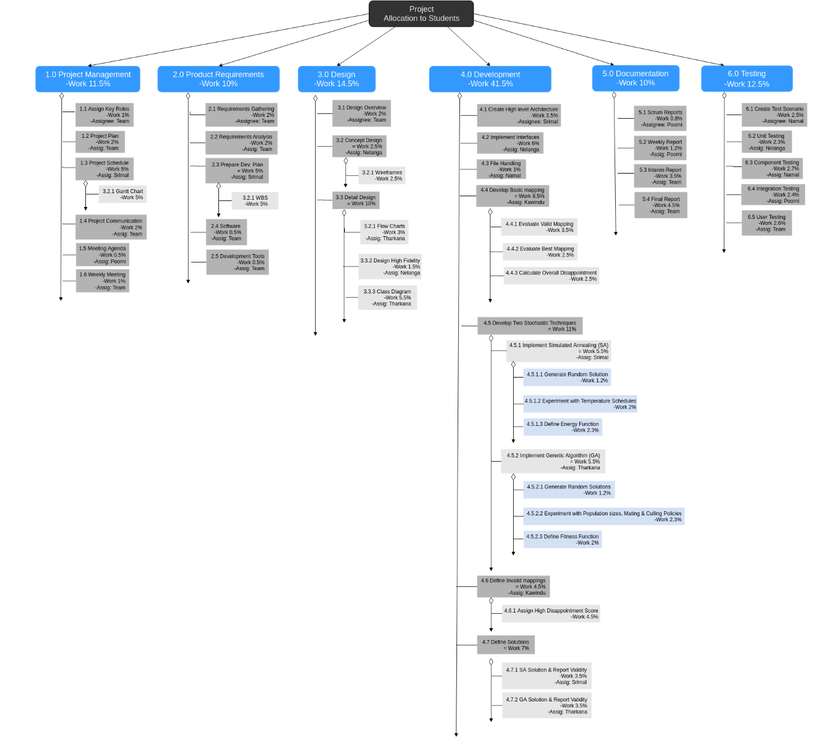

See more - <https://goo.gl/nOQ5ec>

* 1. **Flow Chart**

**C:\Users\Kavindu Narathota\Downloads\Stochastic for Resource Allocation.png**

See more - <https://goo.gl/oz7pCl>

* 1. **Use-case Diagram**

**C:\Users\Kavindu Narathota\Downloads\Use Case (1).png**

See more - <https://goo.gl/94Ub7Q>

* 1. **Mock User Interfaces**

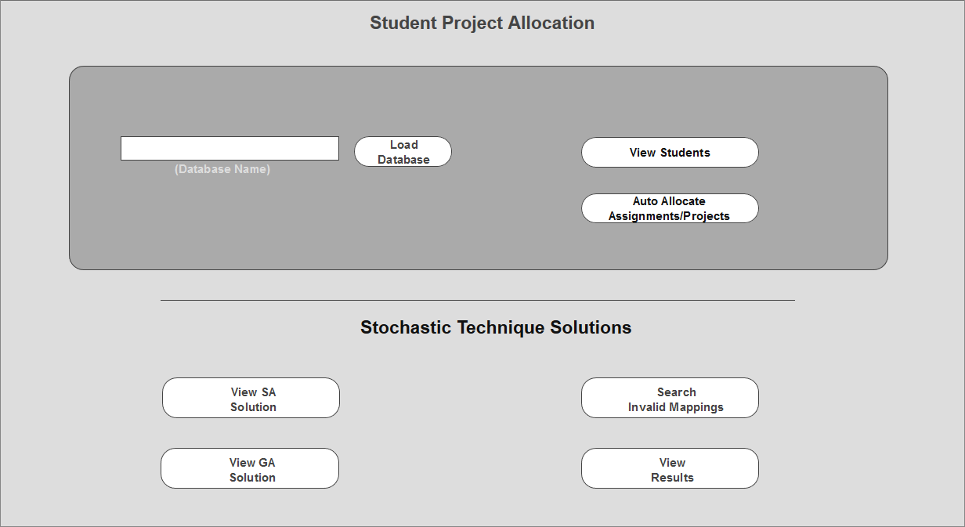

Figure 1 – Home

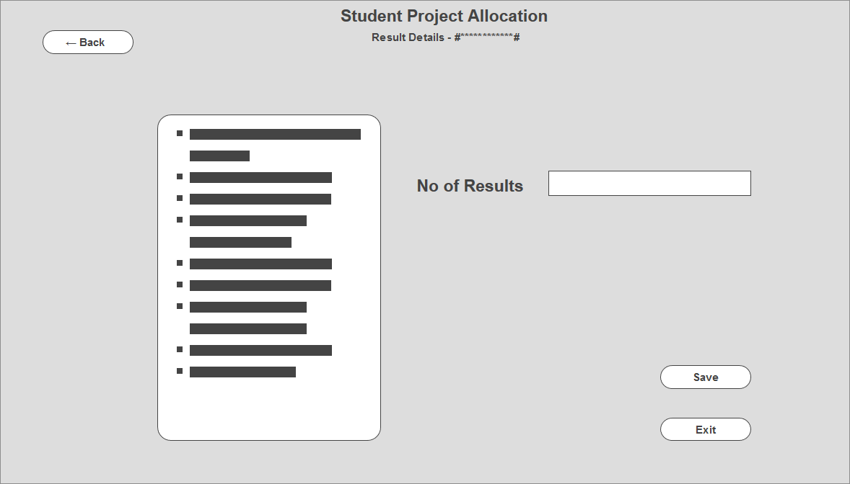

Figure 2 - Results